MADHAV INSTITUTE OF TECHNOLOGY AND SCIENCE, GWALIOR

SUBMITTED BY-

ASMITA JAIN

0901EO201017

SUBMITTED TO-

PROF. APRAJITA KUMARI

**SENSOR TECHNOLOGY LAB 220202**

**EXPERIMENT - 7**

**AIM:**

To study about the Bio-sensors(Pulse rate sensor).

**THEORY:**the heartbeat/pulse rate sensor is based on the principle of **Photoplethysmography.**

The sensor measures the change in volume of blood through any organ of the body which causes a change in the light intensity through that organ.

**Photoplethysmography (PPG):**

PPG makes uses of low-intensity infrared (IR) light. When light travels through biological tissues it is absorbed by bones, skin pigments and both venous and arterial blood. ... The voltage signal from PPG is proportional to the quantity of blood flowing through the blood vessels.

There are 2 types of PPG:

1. Transmission type
2. Reflection type

The most commonly used and accurate technique is “Transmission” type.

Transmission types measure pulse waves by emitting red or infrared light from the body surface and detecting the change in blood flow during heart beats as a change in the amount of light transmitted through the body.

This method is limited to areas where light can easily penetrate, such as the fingertip or earlobe. It uses photoelectric method.

**CIRCUIT DIAGRAM:**

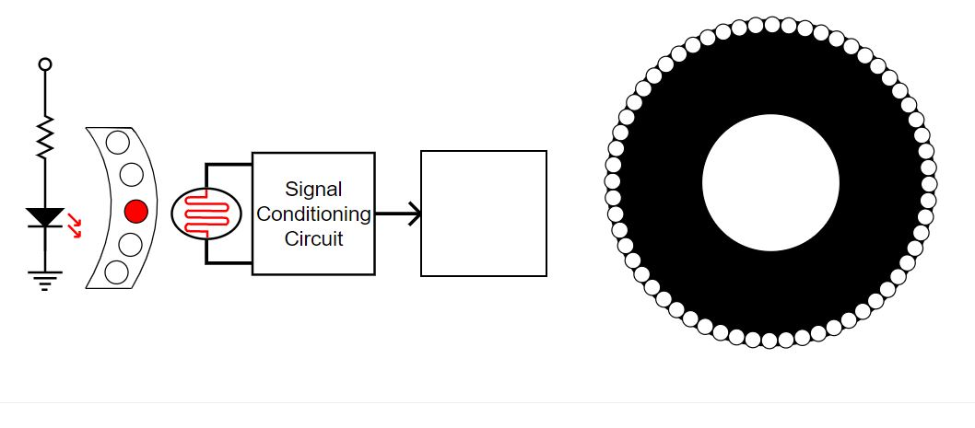

**OBERSERVATION TABLE:**Level 1

|  |  |
| --- | --- |
| **RPM** | **BPM** |
| 0.5 | 30 |
| 1 | 60 |
| 2 | 120 |

Level-2:

|  |  |
| --- | --- |
| **AGE RANGE** | **BPM** |
| 2-6 years | 85 |
| 6-12 years | 103 |
| 12- adults | 88 |

Level-3:

Error: i. Due to misalignment

|  |  |
| --- | --- |
| **AGE** | **BPM** |
| 2-6 years | 98 |
| 6-12 years | 77 |
| 12- adults | 78 |

1. Error due to effect of stray lights.

**RESULT:**

Hence, we have studied about pulse rate sensor and its principle.